https://www.nlog.nl/nlog-mapviewer/brh/2569923610?lang=nl
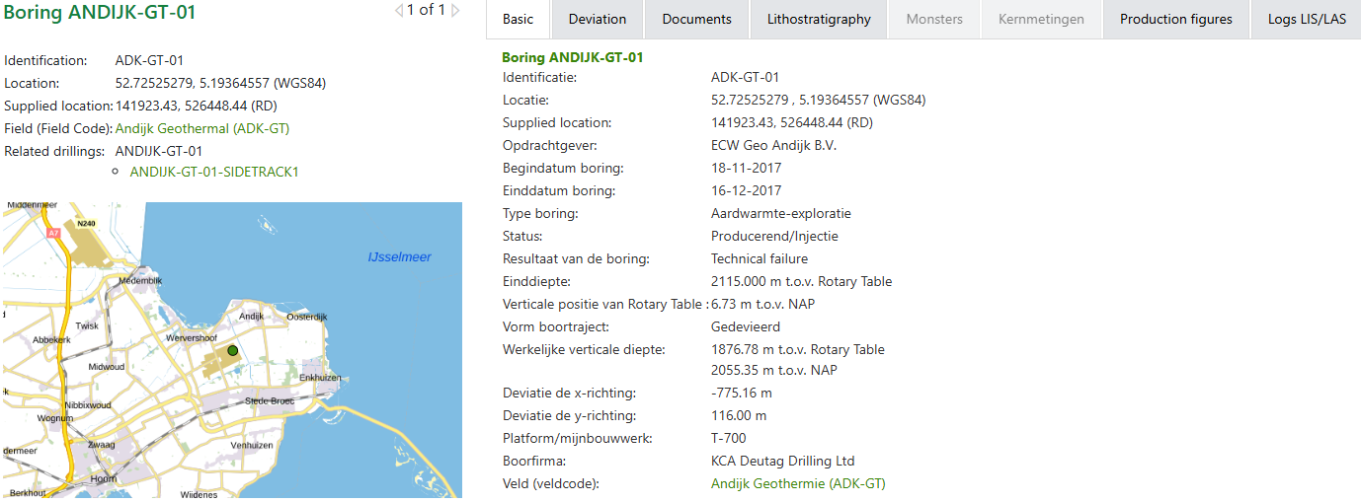
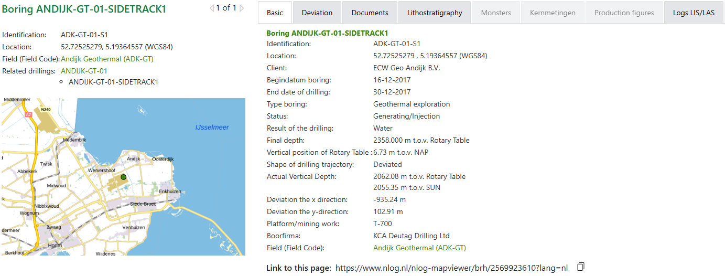

Boring ANDIJK-GT-01
Categorie | Document
Borehole/Well - Final Report | End of Job Report Well Clean-out(28 Nov 2018)  Drillers End of Well Report(31 Jan 2018)
Documents with profile data of the borehole | Actual Wellpath Report(16 Dec 2017)  Technical Log (Composite)(0-2115)(22 Dec 2017)
Documents with test result borehole | Andijk Well Test Analysis(23 Nov 2018)  Well Test Data(29 Dec 2017)
Borehole sample research reports | Biostratigraphy of Miocene strata in the Netherlands(17 Jan 2025)  PVT Analysis Report(13 Feb 2018)  Palynostratigraphy of four wells in the Zuiderzee Low area: updating the statigraphy of the former Breda Fm.(30 Jan 2023)

